TCODE – SHDB

CREATE A NEW RECORDING

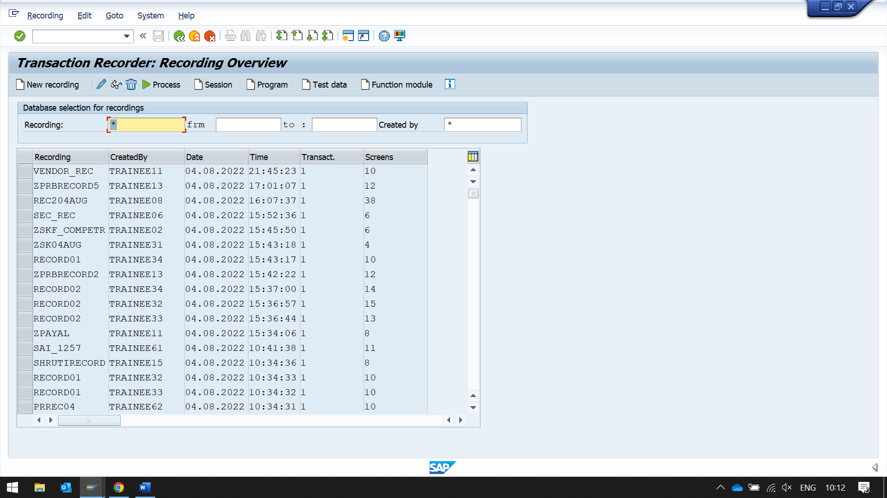

CLICK ON NEW RECORDING BUTTON

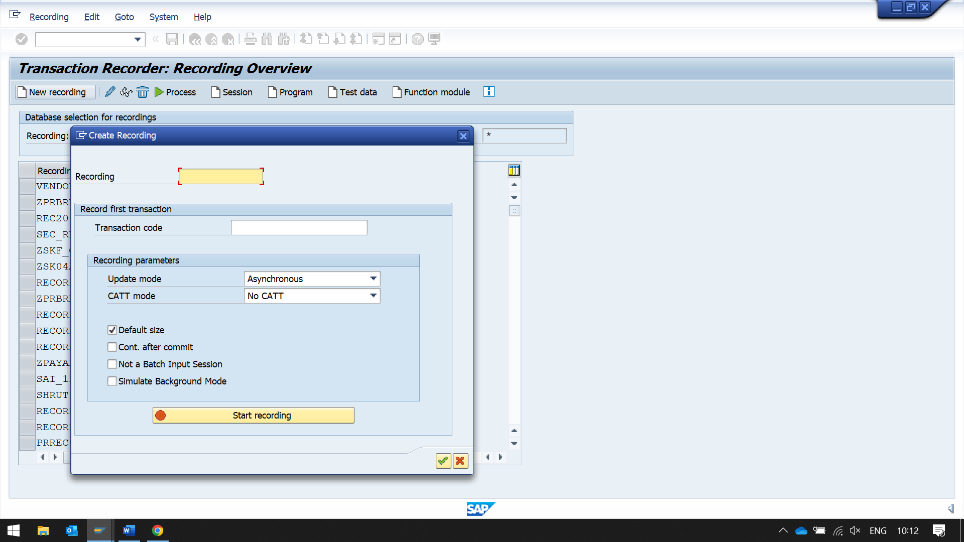

VK11 – ENTERPRISE RECORDS

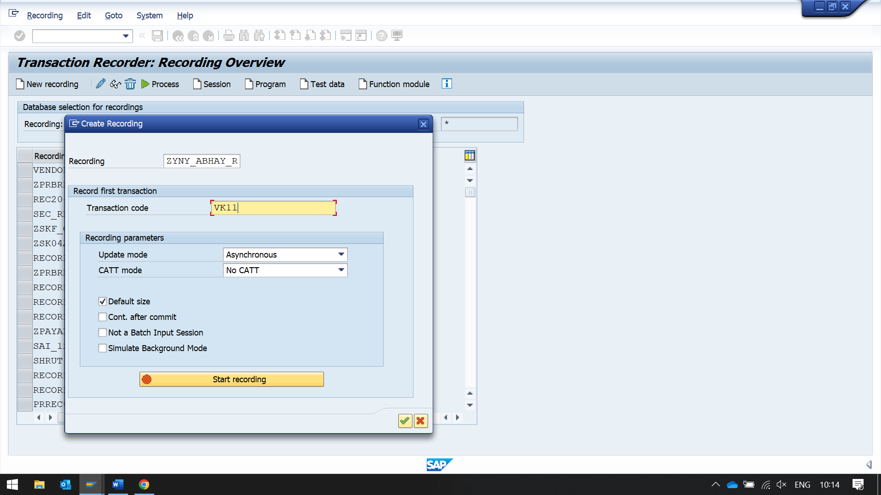

CLICK ON START RECORDING

NOW THE SYSTEM WILL CAPTURE DETAILS OF THIS SCREEN

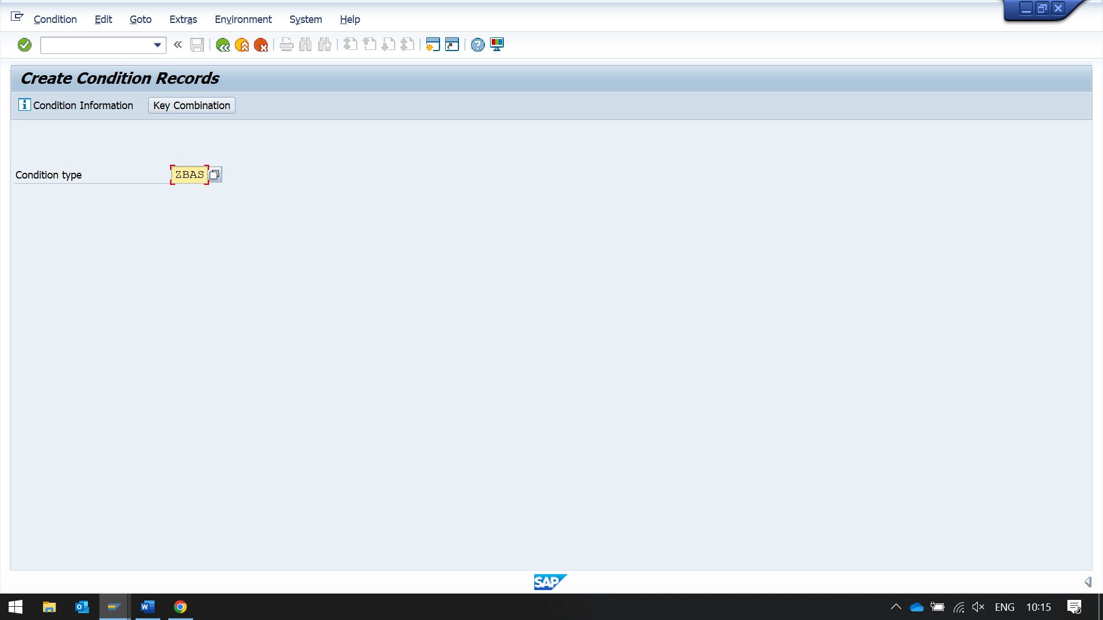CLICK ON KEY COMBINATION

SELECT BASE PRICE IN OPTIONS

THEN CLICK ON KEY COMBINATION

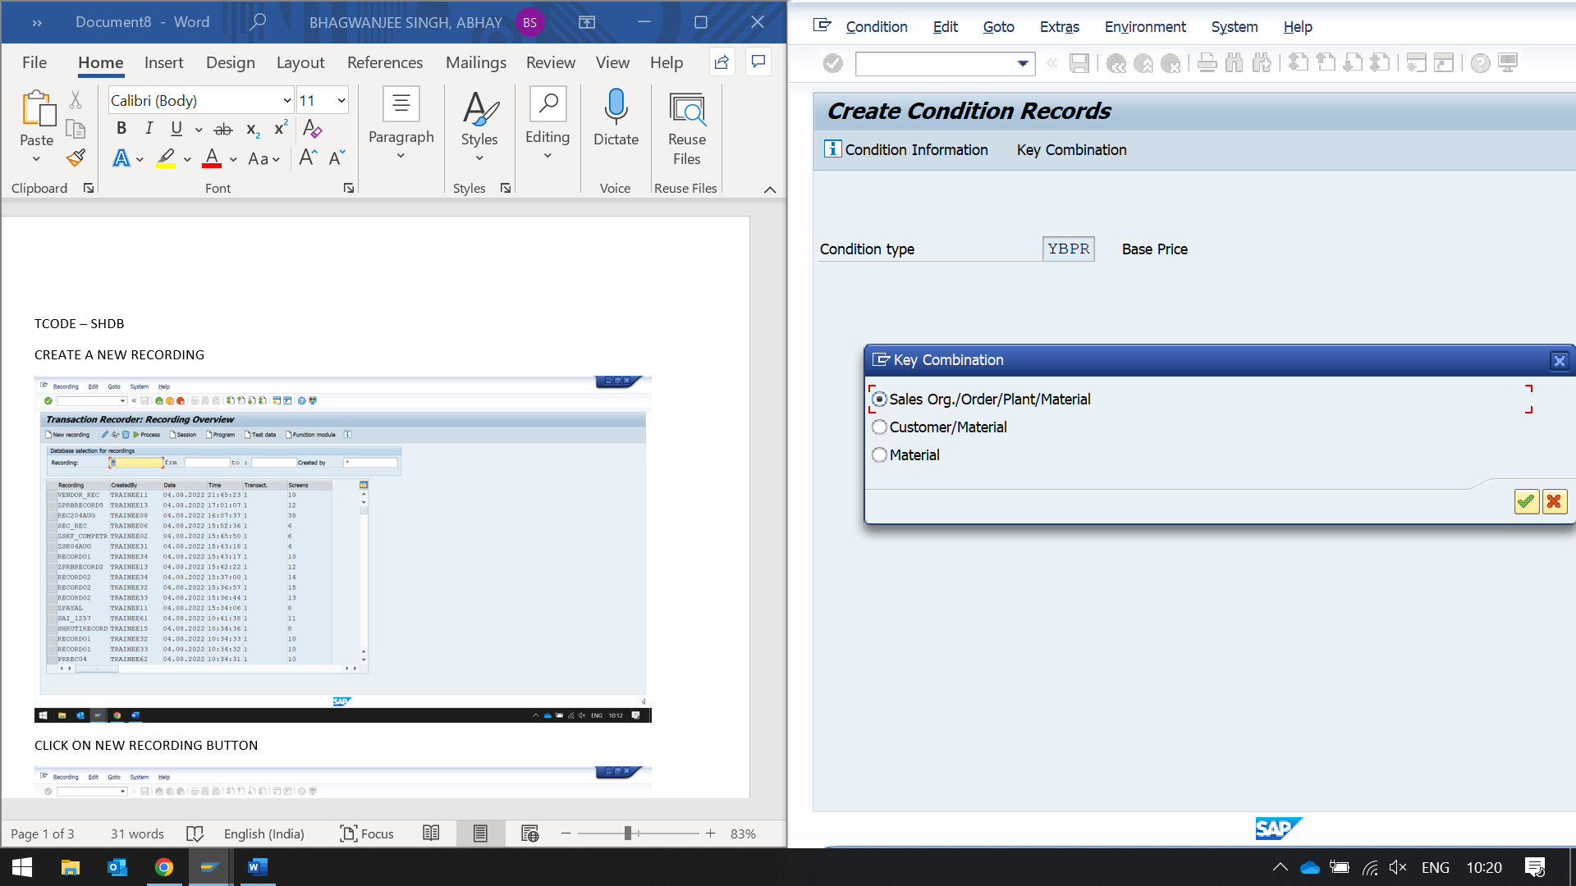

CHOOSE CUSTOMER/MATERIAL

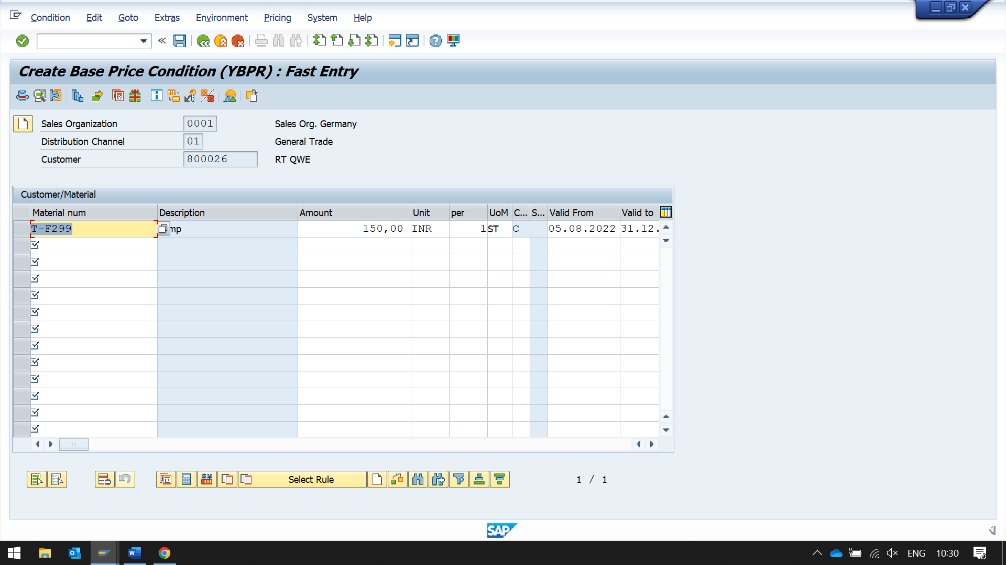

CLICK SAVE

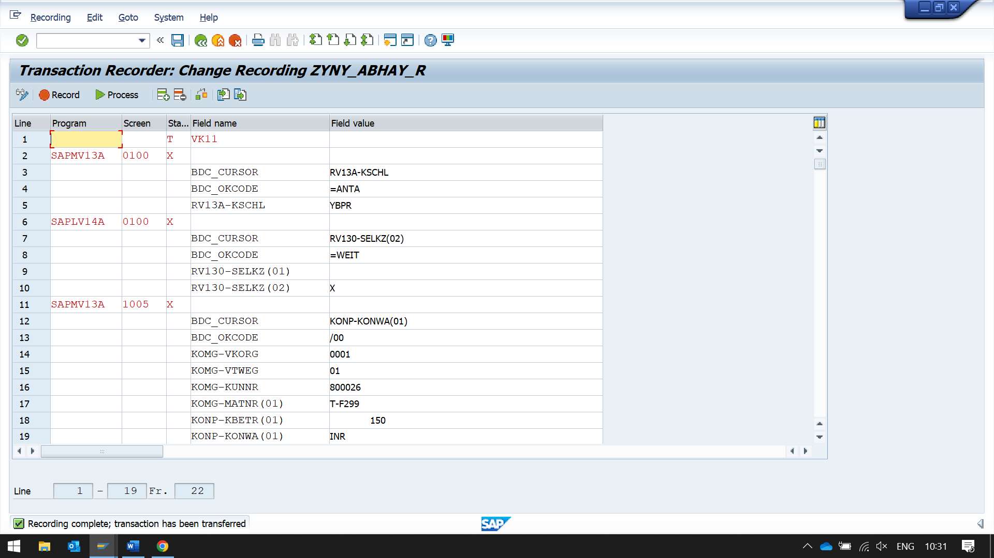

IT RECORDS EVERY INTERACTION OF US TO SCREEN

CLICK ON SAVE

STEP 2

GO BACK

THEN CLICK ON PROGRAM BUTTON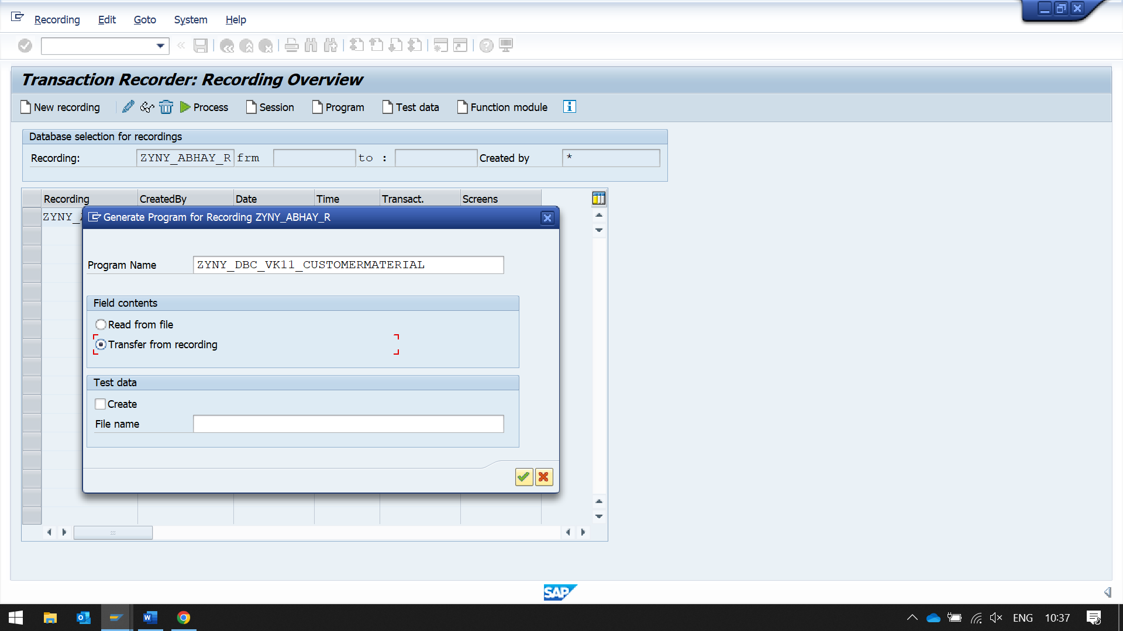

ENTER THE PROGRAM NAME

THEN SELECT TRANSFER FROM RECORDING OPTIONS

CLICK OK

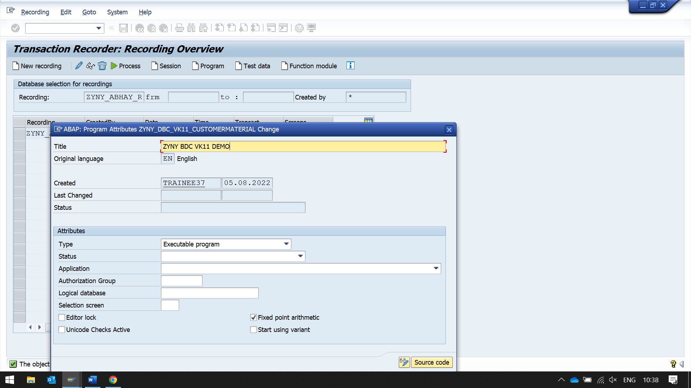

CLICK ON SOURCE CODE

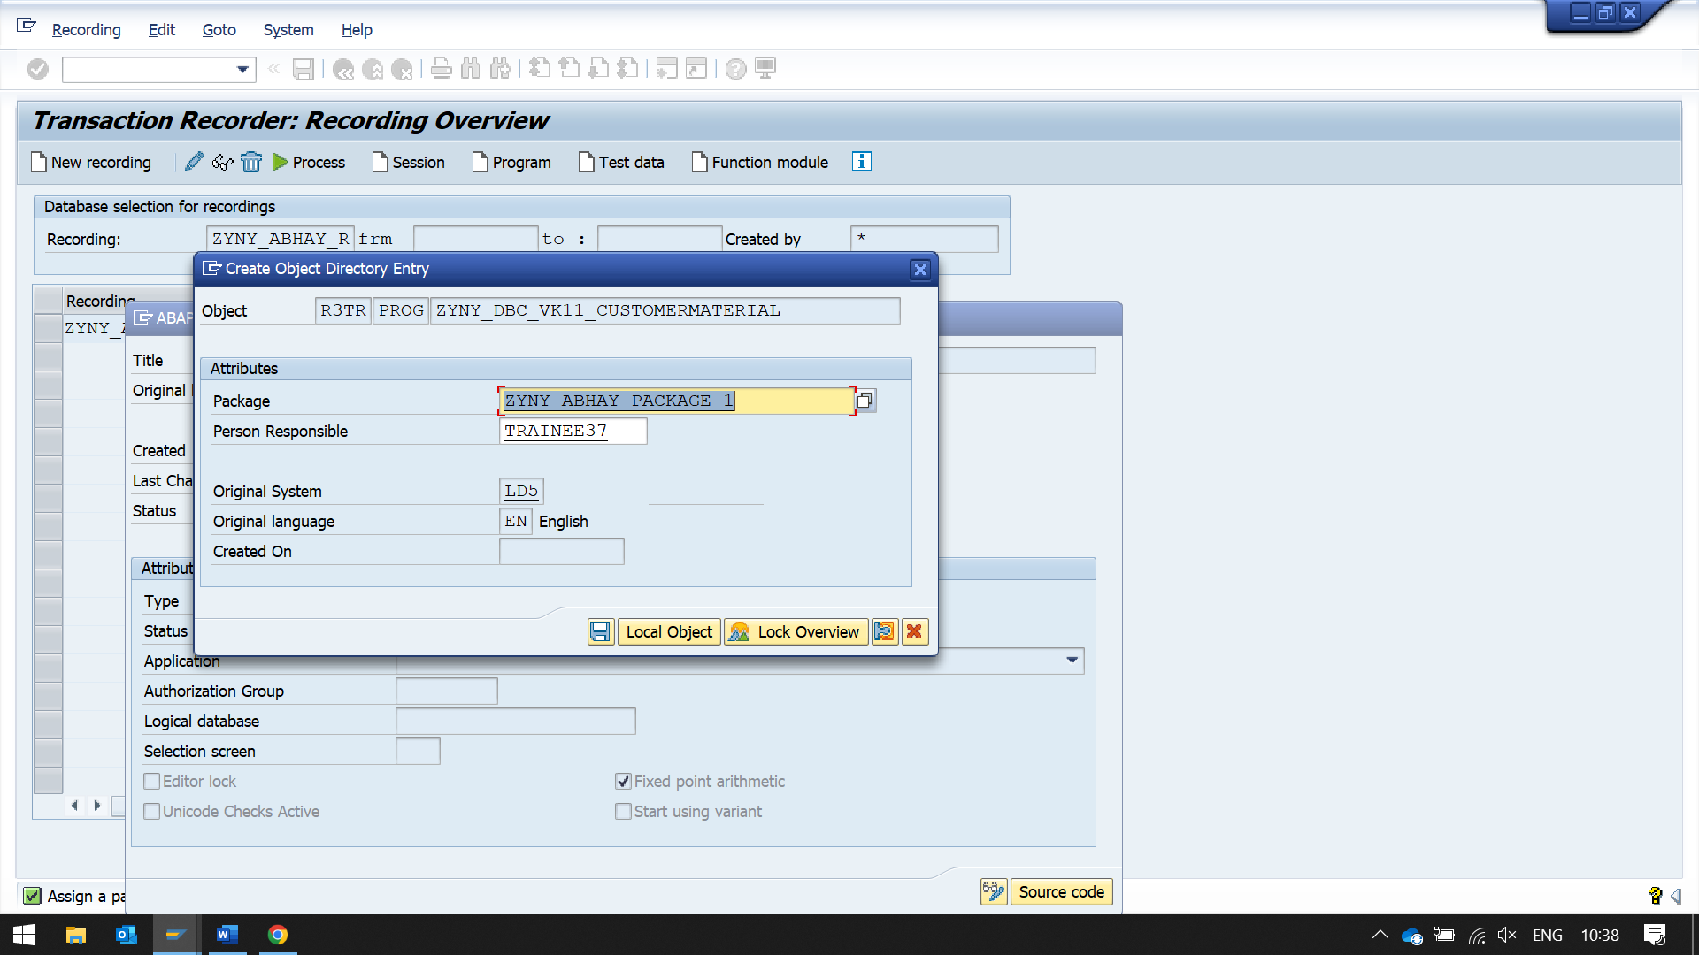

Following program is generated automatically

report ZYNY_DBC_VK11_CUSTOMERMATERIAL  
       no standard page heading line-size 255.  
  
include bdcrecx1.  
  
start-of-selection.  
  
perform open_group.  
  
perform bdc_dynpro      using 'SAPMV13A' '0100'.  
  
perform bdc_field       using 'BDC_CURSOR'  
                              'RV13A-KSCHL'.  
perform bdc_field       using 'BDC_OKCODE'  
                              '=ANTA'.  
perform bdc_field       using 'RV13A-KSCHL'  
                              'YBPR'.  
perform bdc_dynpro      using 'SAPLV14A' '0100'.  
perform bdc_field       using 'BDC_CURSOR'  
                              'RV130-SELKZ(02)'.  
perform bdc_field       using 'BDC_OKCODE'  
                              '=WEIT'.  
perform bdc_field       using 'RV130-SELKZ(01)'  
                              ''.  
perform bdc_field       using 'RV130-SELKZ(02)'  
                              'X'.  
perform bdc_dynpro      using 'SAPMV13A' '1005'.  
perform bdc_field       using 'BDC_CURSOR'  
                              'KONP-KONWA(01)'.  
perform bdc_field       using 'BDC_OKCODE'  
                              '/00'.  
perform bdc_field       using 'KOMG-VKORG'  
                              '0001'.  
perform bdc_field       using 'KOMG-VTWEG'  
                              '01'.  
perform bdc_field       using 'KOMG-KUNNR'  
                              '800026'.  
perform bdc_field       using 'KOMG-MATNR(01)'  
                              'T-F299'.  
perform bdc_field       using 'KONP-KBETR(01)'  
                              '             150'.  
perform bdc_field       using 'KONP-KONWA(01)'  
                              'INR'.  
perform bdc_dynpro      using 'SAPMV13A' '1005'.  
perform bdc_field       using 'BDC_CURSOR'  
                              'KOMG-MATNR(01)'.  
perform bdc_field       using 'BDC_OKCODE'  
                              '=SICH'.  
perform bdc_transaction using 'VK11'.  
  
perform close_group.

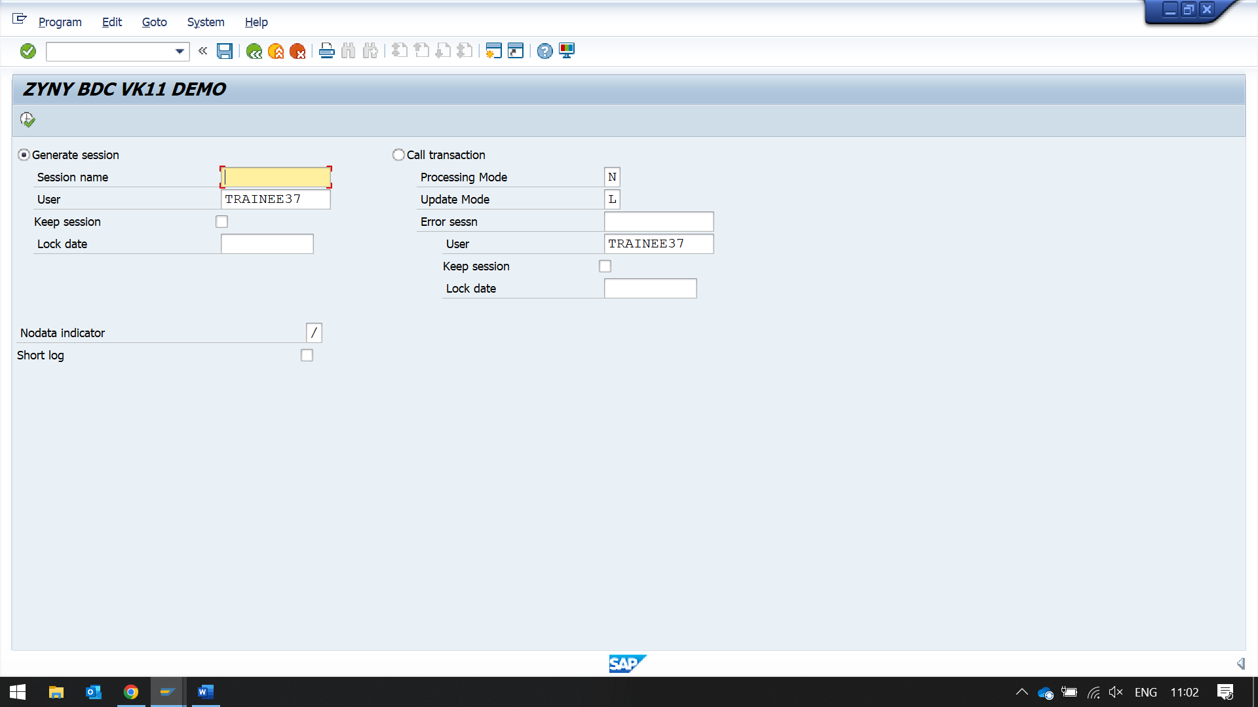

First using call transaction method

While using processing mode - A

This is like replay of what we did while recording the screen

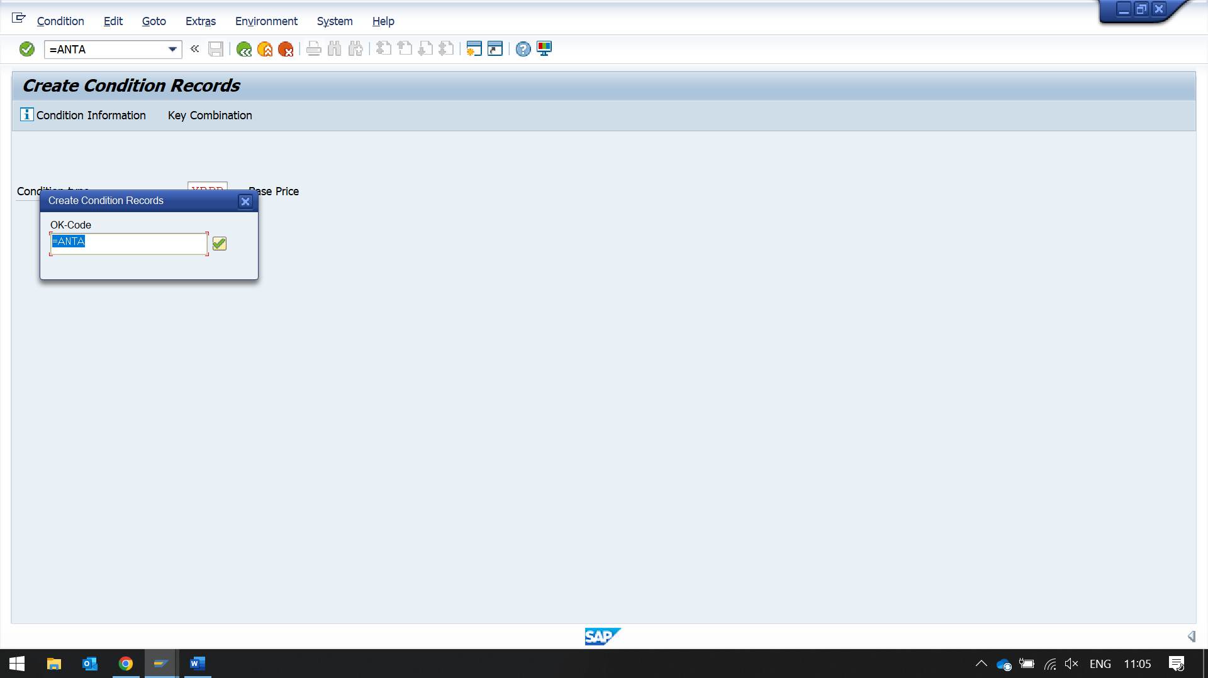

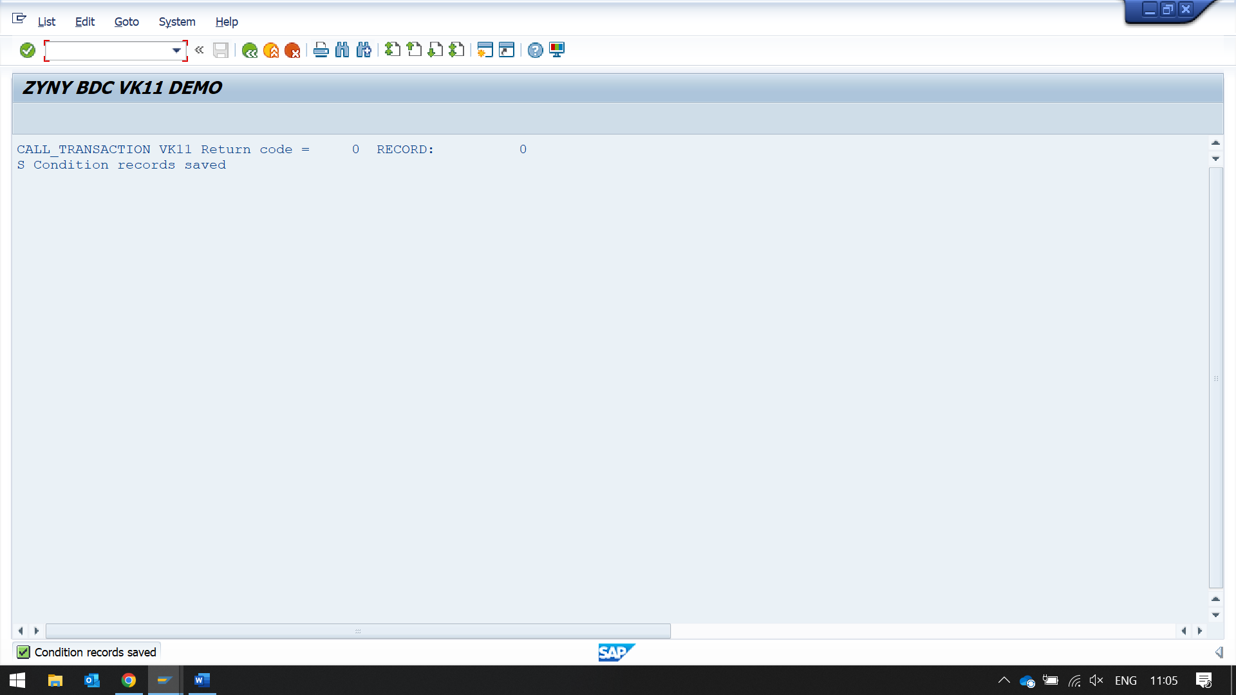

Now by using session method

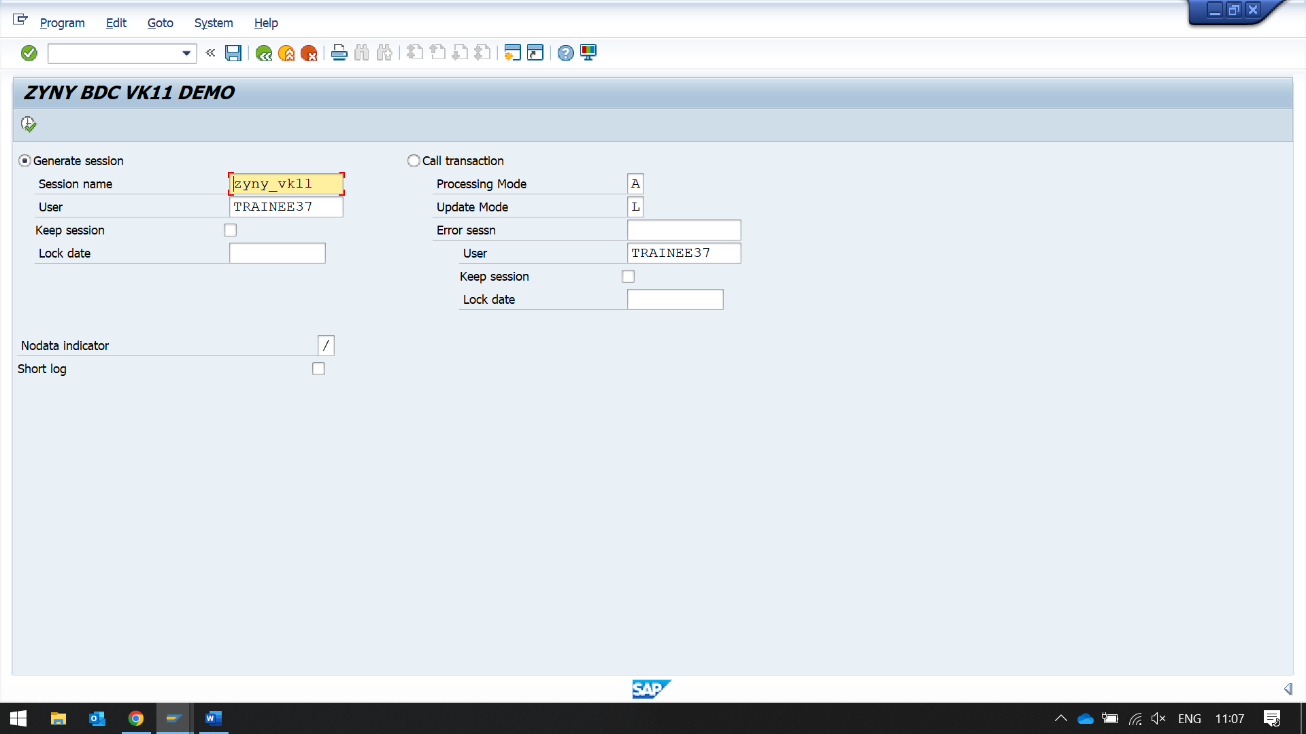

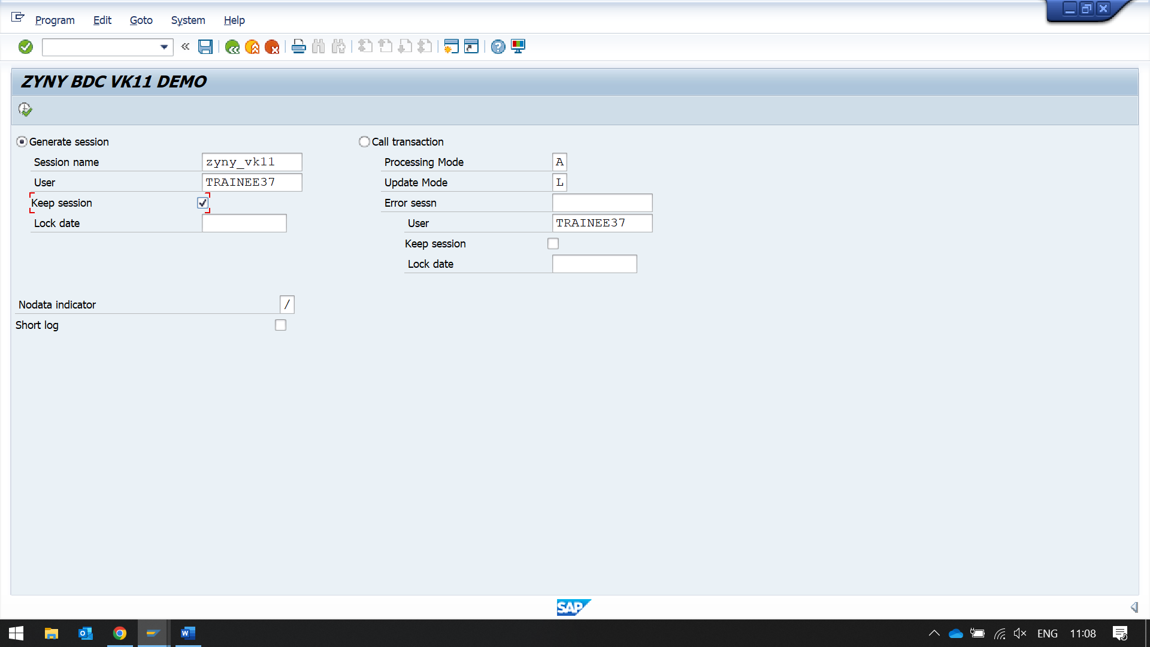

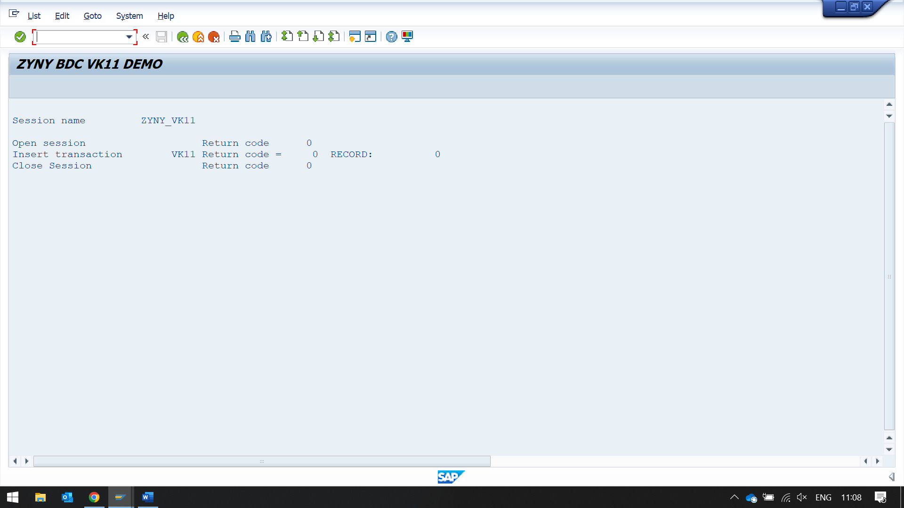

Now to see this session

Go to sm35

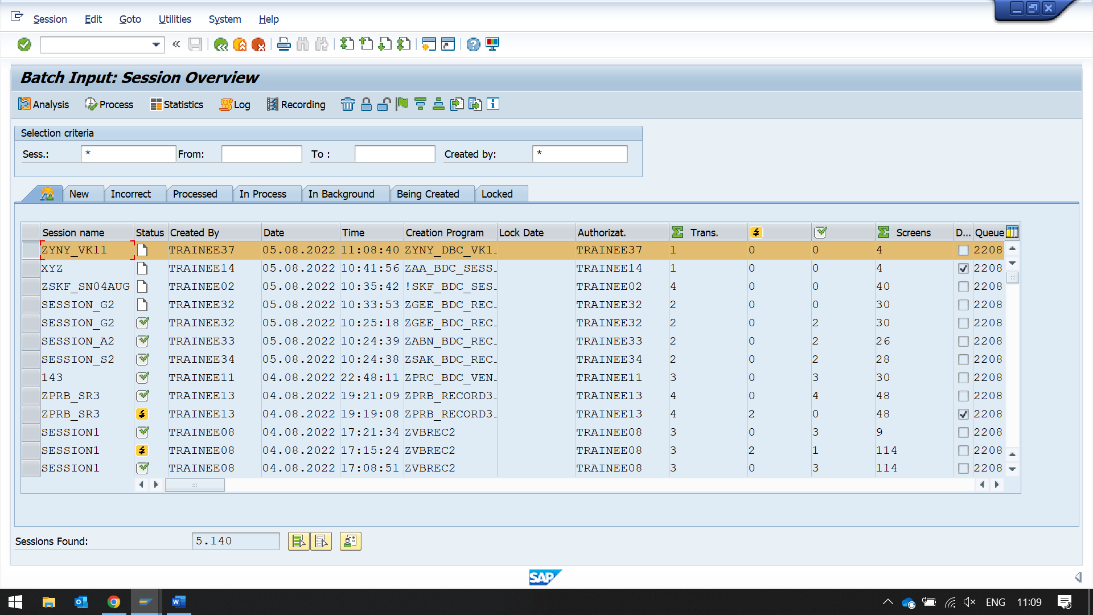click on process

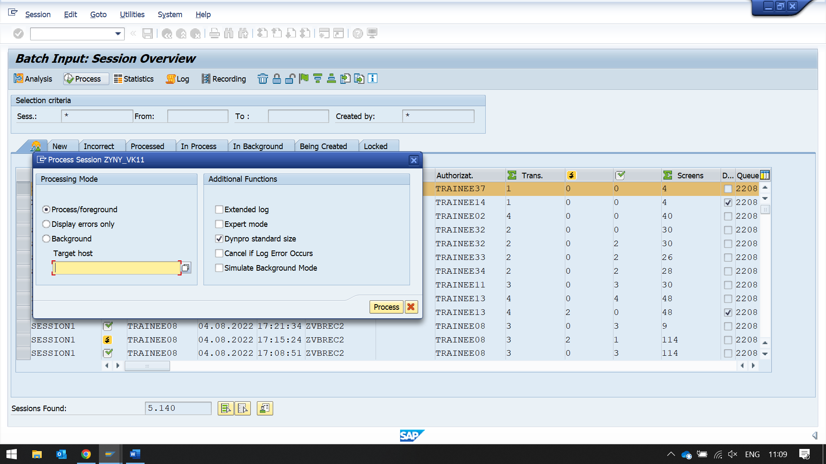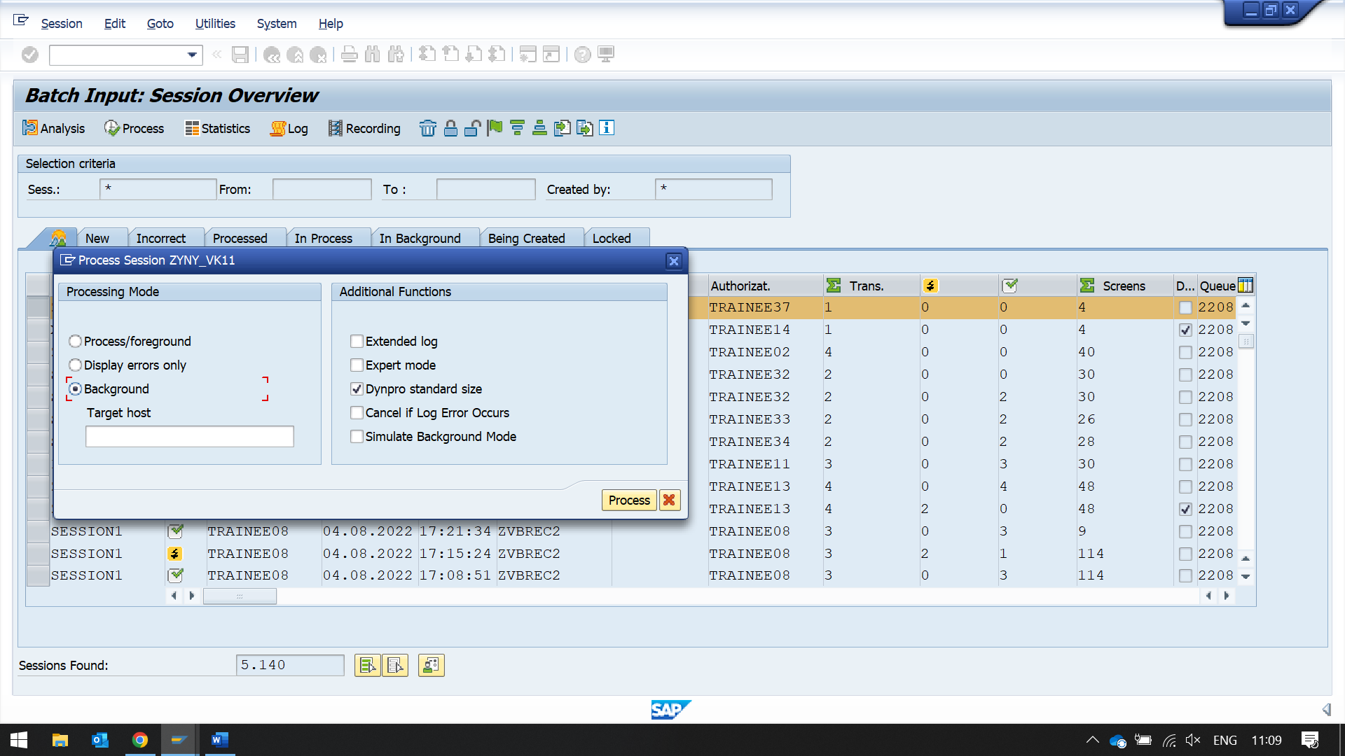

Now in the status, you can see the green icon

